Student Management System

1) Create Database Name : ‘school_db’
2) Create Student Table

2) CREATE TABLE students(
id INT AUTO_INCREMENT PRIMARY KEY,
name VARCHAR(25),
age INT(50),
class VARCHAR(25),
marks VARCHAR(25),
city VARCHAR(25)
)
Output:
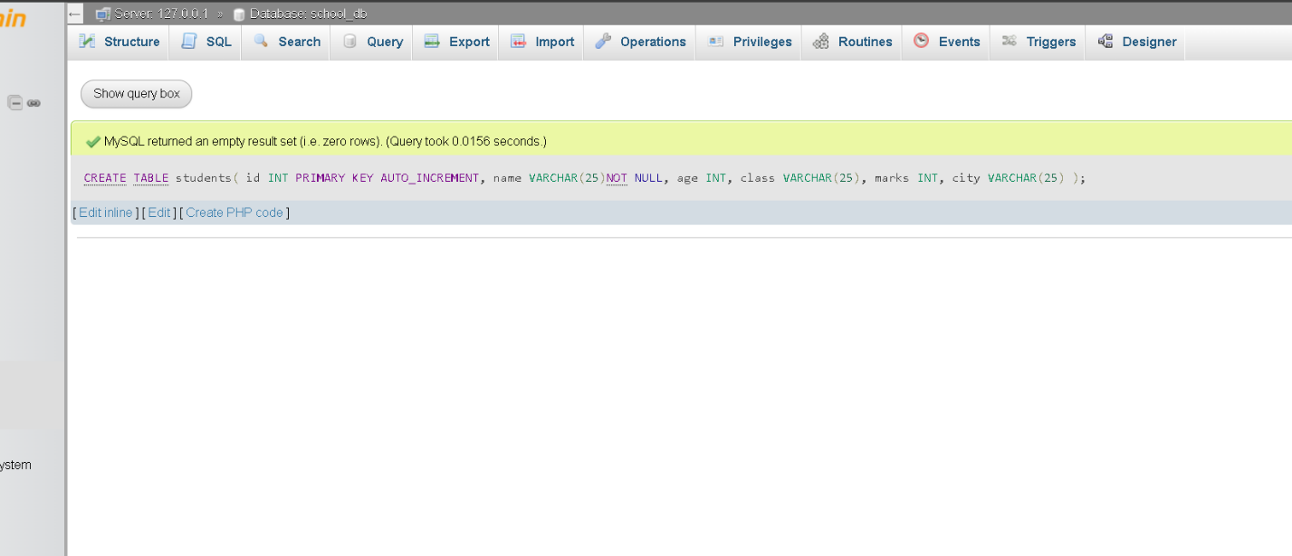

3// Insert At Least 5 Student

INSERT INTO students (name, age, class, marks)
VALUES
('Ahmed', 18, '10th', 85),
('Ali', 16, '9th', 78),
('Hassan', 20, '12th', 92),
('Usman', 17, '11th', 67),
('Bilal', 15, '10th', 74);

Output:
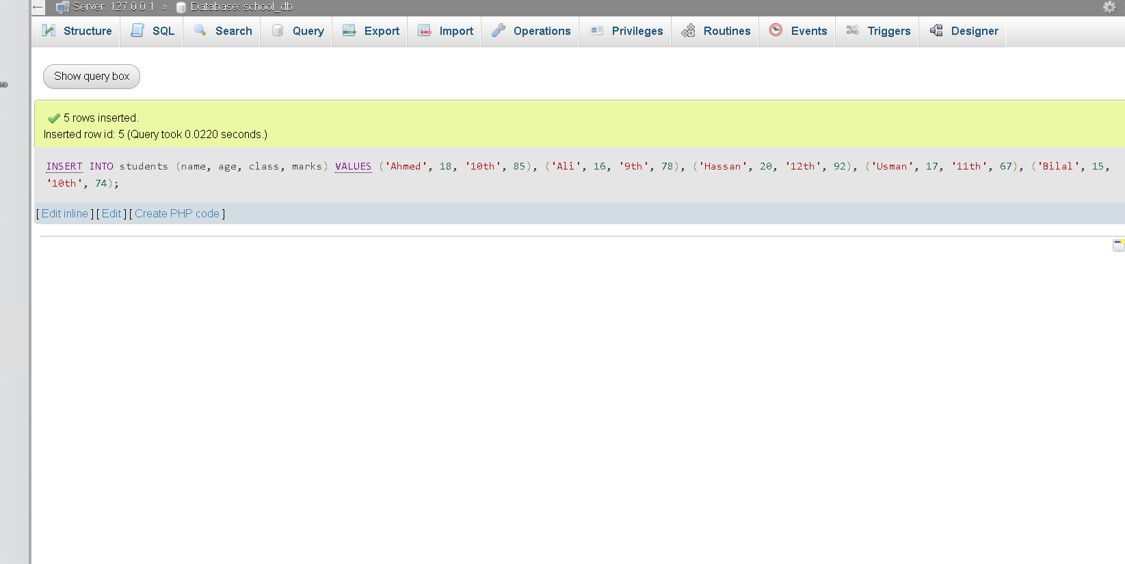

4// Filter Students Marks > 60 And City = ‘Karachi’ Student

SELECT name,city FROM students WHERE marks > 60 AND city = 'karachi'
Output:
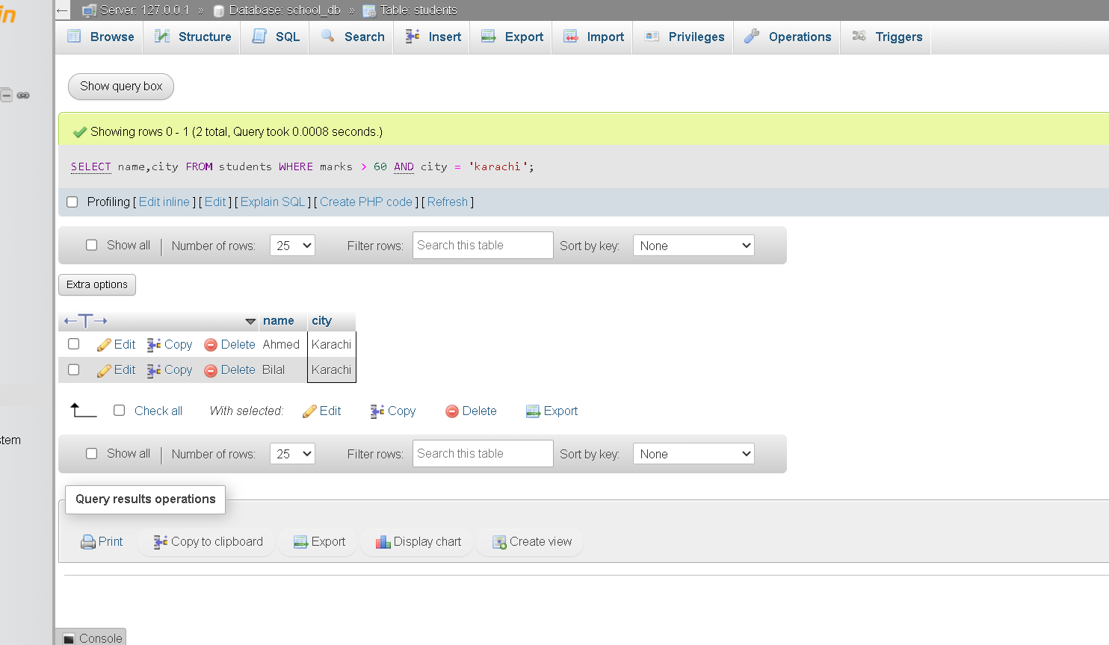

5// Increase Marks By 10 Where Marks < 50

UPDATE students
SET marks = marks + 10
WHERE marks < 50;

Output:
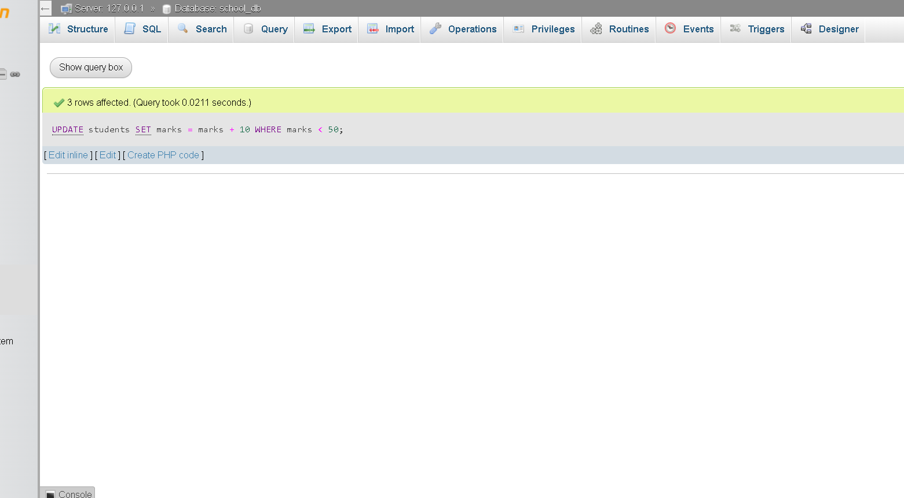

6// Delete student Where Age < 15

DELETE FROM students WHERE age < '20';

Output:
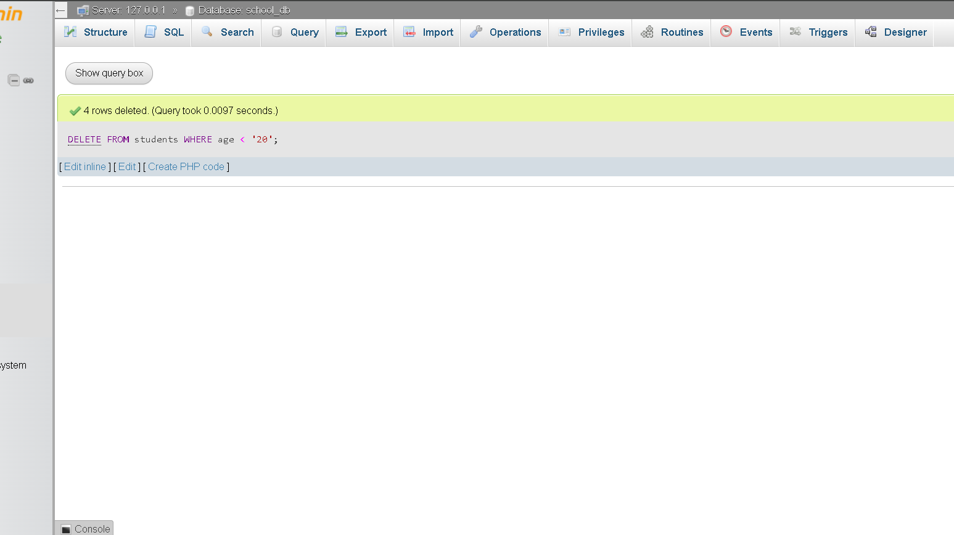

7// Limit Condition Use:

SELECT *
FROM students
ORDER BY marks DESC
LIMIT 3;

Output:
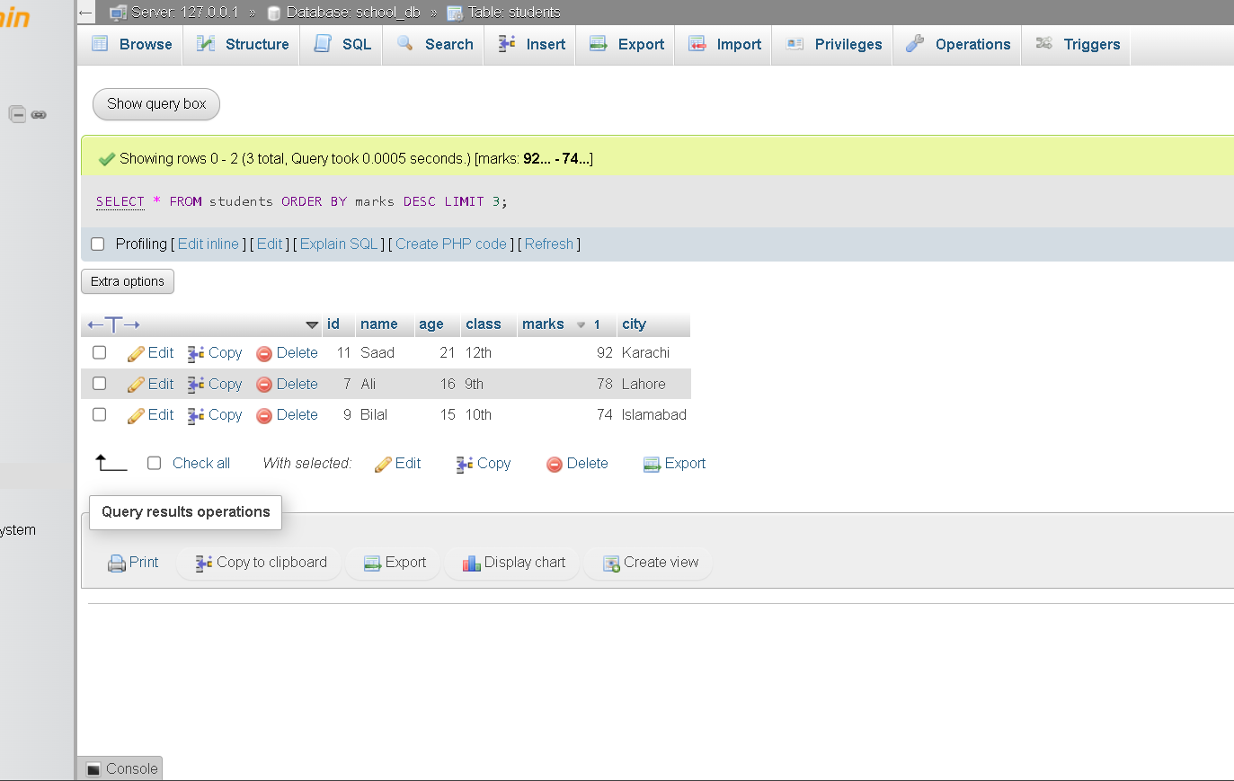

8// Filter Data By Marks & City:

SELECT *
FROM students
WHERE marks >= 70
AND city = 'Lahore';

Output:
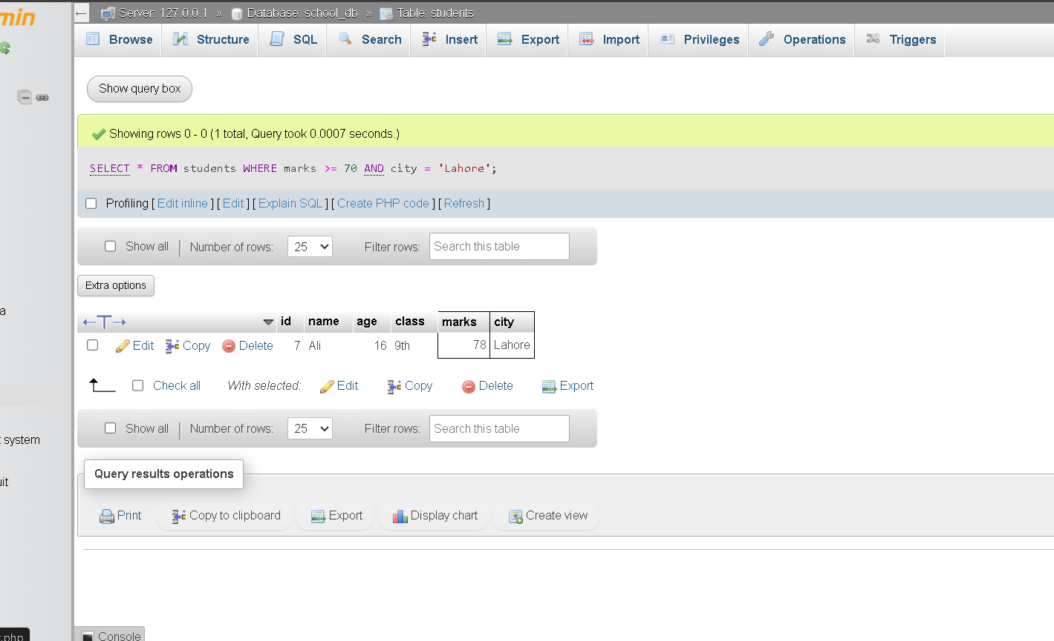

9// Count Each City Students:

SELECT city, COUNT(*) AS total_students
FROM students
GROUP BY city;

Output:
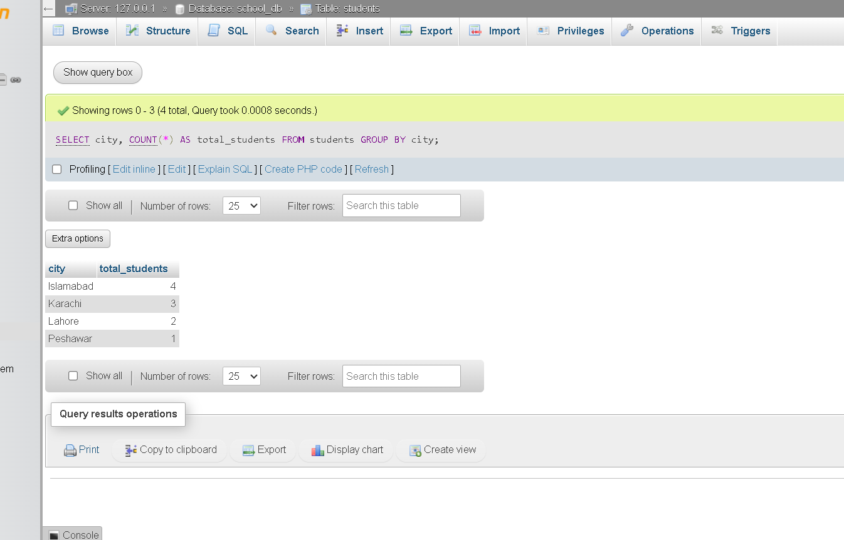

10// Count Each City Students:

1) Sort by marks (descending)
SELECT *
FROM students
ORDER BY marks DESC;

Output 1:
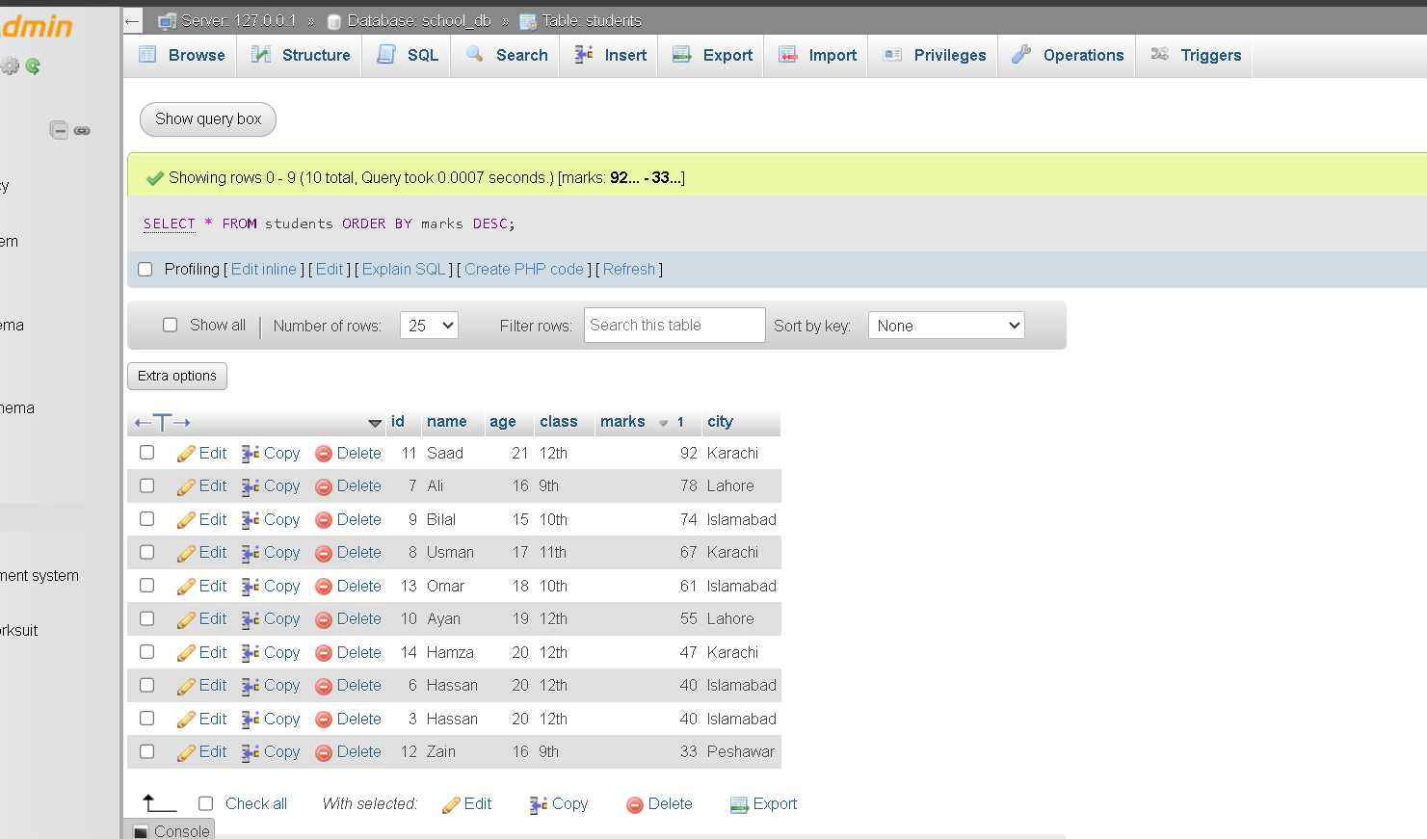

2) Sort by marks (descending)
SELECT *
FROM students
ORDER BY marks ASC;

Output 2:
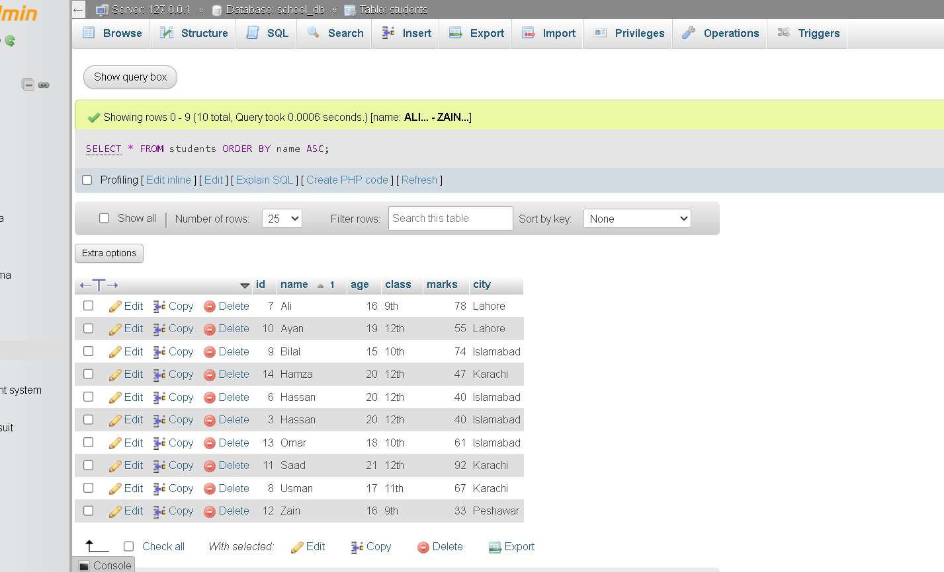

1) Count Students
SELECT COUNT(*) AS total_students
FROM students;

Output 1:

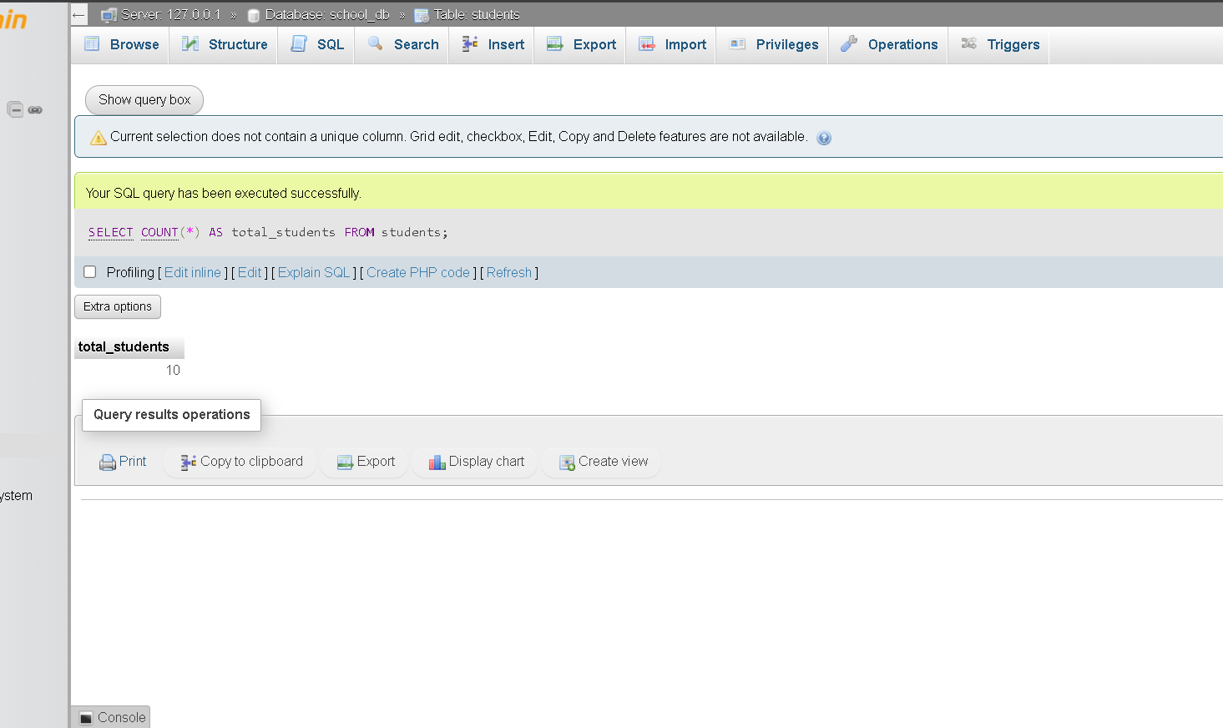

2) Average marks
SELECT AVG(marks) AS average_marks
FROM students;

Output 2:

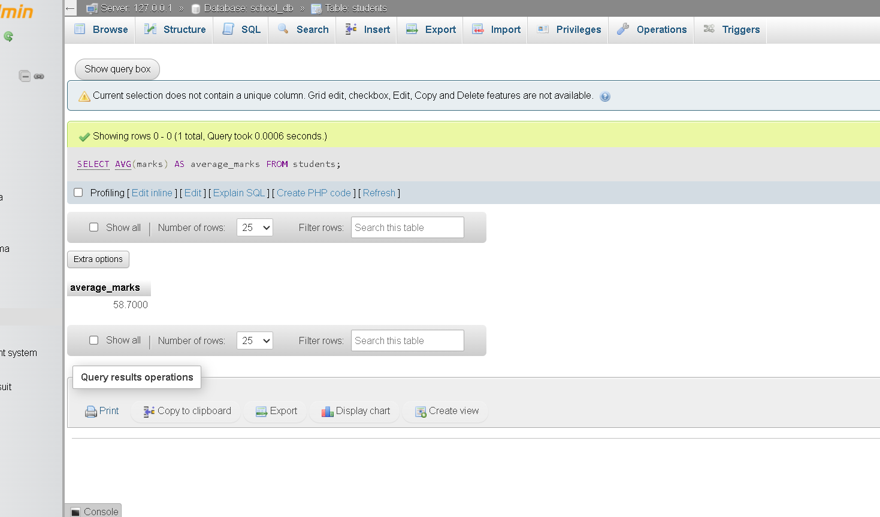

3) Average marks
SELECT MAX(marks) AS highest_marks
FROM students;

Output 3:

